# 09/09/2020

<INSURANCE AGENT>

<IAW0001>

Program Specifications (Client Server Environment)

**Record of Release**

|  |  |  |  |  |  |
| --- | --- | --- | --- | --- | --- |
| **Version No.** | **Modified By** | **Reviewed By** | **Authorized By** | **Release Date** | **Modifications Done** |
| 1 | Yashasvi Thakur | Shreya Shetty | Yashasvi Thakur | 12/09/2020 | Backend Design |
| 2 | Shreya Shetty | Shreya Shetty | Yashasvi Thakur | 12/09/2020 | Screen Design |
| 3 | Bhavika Shriavstava | Shreya Shetty | Yashasvi Thakur | 12/09/2020 | Introduction |
| 4 | Ritu Pujari | Shreya Shetty | Yashasvi Thakur | 12/09/2020 | Database design |
| 5 | Bharvi Sharma | Shreya Shetty | Yashasvi Thakur | 12/09/2020 | Database design |

**Table of Contents**

***1.0 Introduction 3***

*1.1 Objective 3*

*1.2 Function Specification reference details 3*

*1.3 References 3*

***2.0 Database Design 3***

*2.1 Module Related ERD 3*

*2.2 Tables 3*

*2.3 Indexes 3*

*2.4 Views 4*

*2.5 Others 4*

***3.0 Screen Design 4***

*3.1 <Name> 4*

***4.0 Reports Design 5***

*4.1 <Title of the Report > 5*

***5.0 Backend Design 8***

*5.1 Index of Reference 8*

*5.2 <Library Name> 8*

# **Introduction**

## **Objective**

The objective of this document is to provide the detailed technical specifications about Home Page, module of Insurance Agent Portal. This document includes information on the Database Design, Backend Programming, Screens, and Reports layouts.

## **Function Specification reference details**

|  |  |  |
| --- | --- | --- |
| **Business Function Name** | **Program type** | **Name of the Program** |
| Home Page  After Login in home screen of the portal appeared which contains the latest policies, search bar, module tab | Database diagrams , web browsers | Insurance Agent Portal (Home Screen) |

## **References**

|  |  |
| --- | --- |
| **Document Name** | **Purpose** |
| DLD SSAD | To explain Detailed Level Designing of this Project |

# **Database Design**

## **Module Related ERD**

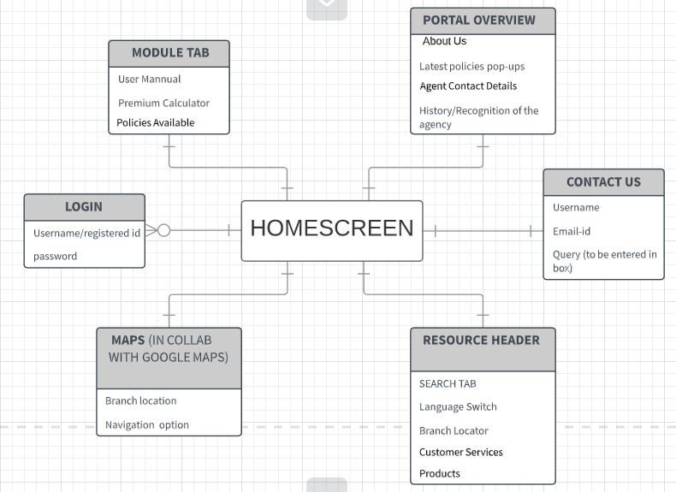

## **Tables**

* + 1. **Owned by Module**

|  |  |  |
| --- | --- | --- |
| **Sr.No.** | **Table Name** | **Table Description** |
| 1. | Login | Login is used by the user to access the portal account |
| 2. | Module Tab | It is the UI where content is separated into different panes |
| 3. | Portal Overview | The latest policies are shown using an overlay. |
| 4. | Contact Us | It allows the user to get in touch with the admin and get the queries cleared. |
| 5. | Search Box | It allows user to enter a query to be searched for in a database |
| 6. | Resource Header | It contains the hyperlinks of the essential content. |
| 7 | Maps | . Google Maps offers an API that allows maps to be embedded on our websites, |

* + 1. **Referred by Module**

|  |  |  |
| --- | --- | --- |
| **Sr.No.** | **Table Name** | **Table Description** |
| -- | -- | -- |

## **Views**

- Views are not required as the above tables are sufficient.

# **Screen Design**

## Homepage (iaw-home)

* + 1. **Brief description / Functionality**

Functions Provided:- Logo, navigation, customer service etc. can be accessed by the customer.

1. respective buttons

Interfaces to other modules: Homepage will give the user access to other modules that are branch locator , Navigation bar (search bar) and customer services.

Logic of the module:

1. User will be able to view log-in page with register new account link
2. User will be able to click onto the register new account link
3. User will be able to enter all the required information on the register new account link
4. User will be able to successfully register a new account
5. User will be able to Log-in with using the same credentials which he used to register an account
6. Once the user logged in, the user will be able to view the home page
7. The user will be able to view the branch locator , logo , customer service
8. The user will be able to click on the ‘Profile’ tab in the bar
9. The user will be able to view his profile with the details he used to register the account
10. The user will be able to click onto the ‘Home’ tab to go back to the Home page

Inputs / Outputs:

Once put in the link of the website on the browser, the homepage of the insurance agent portal will be visible and can be accessed.

List of exceptions that can occur:

1. Slow performance due to server overload (It might show as page not found)
2. This site will not appear from mobile.
   * 1. **Parameters received**

|  |  |  |
| --- | --- | --- |
| **Parameter** | **Data Type** | **Description (usage)/(Constraint)** |
| Insured ID | int | Not Null |
| Name | String | Not Null |
| Gender | String | Not Null |
| DOB | date time | Not Null |
| Industry | String | Not Null |
| Occupation | String | Not Null |
| Address | String | Not Null |
| pin | int | Not Null |

* + 1. **Screen / reports / programs / interfaces called and parameters passed**

|  |  |  |  |  |
| --- | --- | --- | --- | --- |
| **Sr. No.** | **Screen / Report / Program / Interface Name** | **Description (Usage)** | **Parameter** | **Data Type** |
| 1 | Branch Locator | third party gps for nearest branch | menu-item=bloc | string |
| 2 | Search | Navigates through the website | menu-item= sear | string |
| 3 | Customer Services | information about services provided | menu-item=custsvc | string |

* + 1. **Screen Navigation Logic**

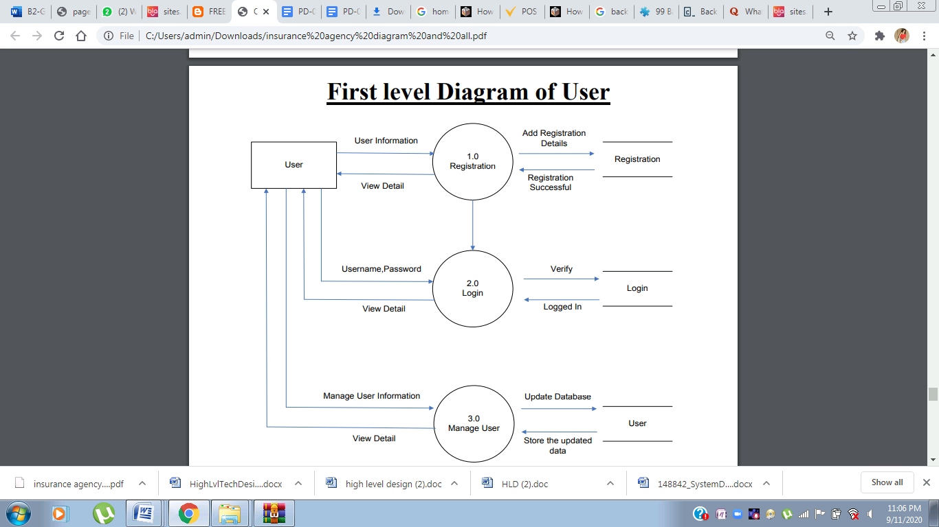

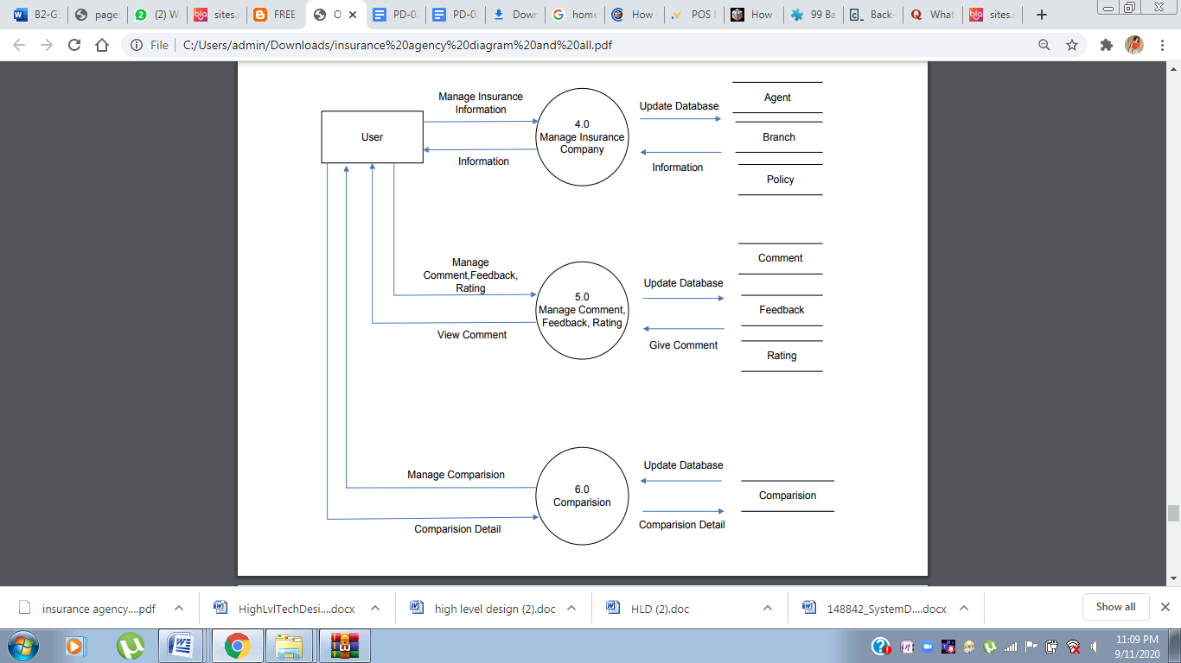

* + 1. **Business rules for data manipulation**

1. Only people in Mumbai can access the portal.
2. Only admin user will be able to change the content on the home screen.
3. The registration age limit is 18 years
   * 1. **Tables/Views used with access modes**

|  |  |  |  |  |
| --- | --- | --- | --- | --- |
| **Table/View** | **Select** | **Insert** | **Update** | **Delete** |
| N/A | - | - | - | - |

all static data , no data fetched from data base

* + 1. **Layout**

|  |  |  |
| --- | --- | --- |
| **Layout Name** | **Type\*** | **Description** |
| Landing Page | Main Screen | A page with informative images |
| Services | Main Screen | information about services provided |
| Policies | Main Screen | Policy information |
| Calculator | Child Screen | Emi calculator |
| User Manual | Child Screen | Guide through the website |
| Branch Locator | Main Screen | third party gps for nearest branch |
| About Us | Main Screen | information about website |
| Contact us | Main Screen | contact information |

* **Type** can be main screen, child screen, dialog box, template, and forms.

* + 1. **Blocks**

#### Landing Page

##### **Block description :** Informative images.

##### **Block level validations :** N/A

#### About Us

##### Block description : information about website.

##### Block level validations : Verified information about the agent.

##### 

#### Services

##### Block description: information about services provided.

##### Block-level validations: N/A

##### 

#### Policies

##### Block description: Types of Policies available

##### Block-level validations: updated and latest policies should be displayed

##### 

#### Branch Locator

##### Block description: third party gps for nearest branch.

##### Block-level validations: Coordinates within Mumbai

##### 

#### Contact us block

##### Block description: helps with queries.

##### Block-level validations: queries considered within mumbai’s geographical boundary.

##### 

* + 1. **Screen Layout**

<Screen dump of the layout. Preferably put it in a separate file and give a reference here. >

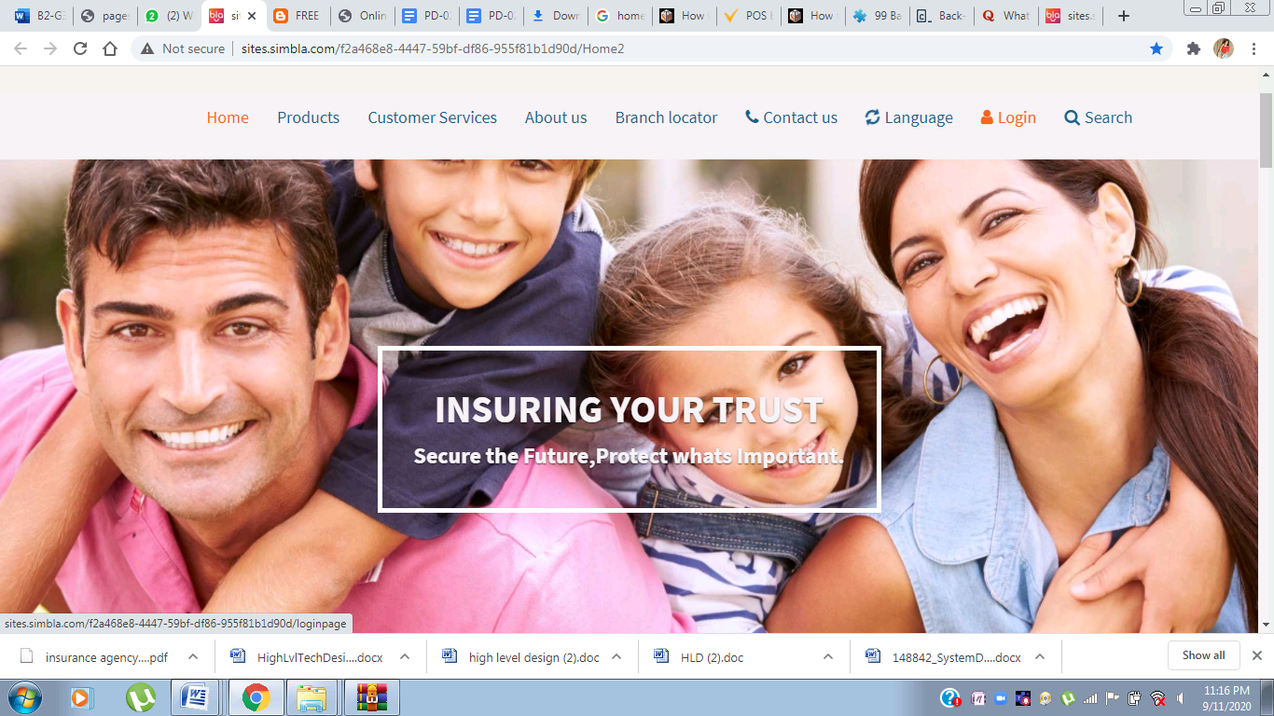

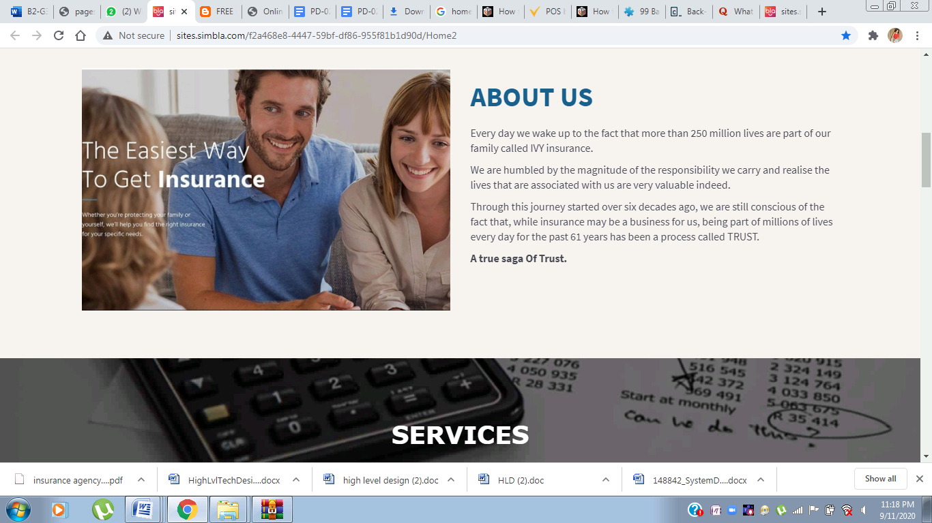

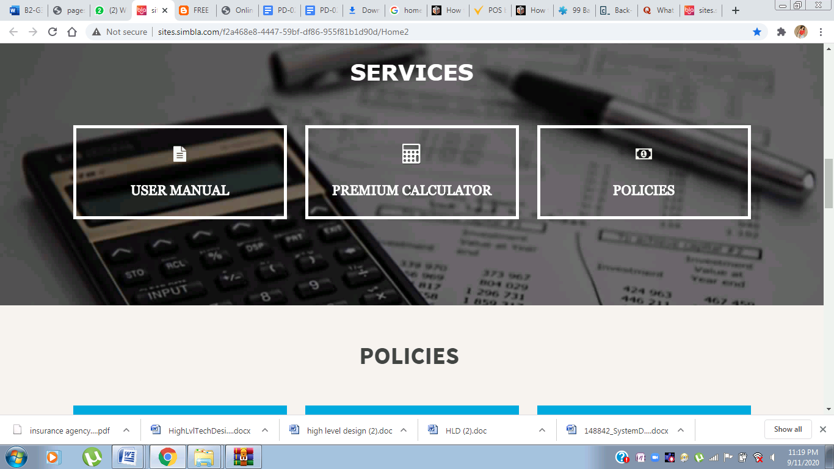

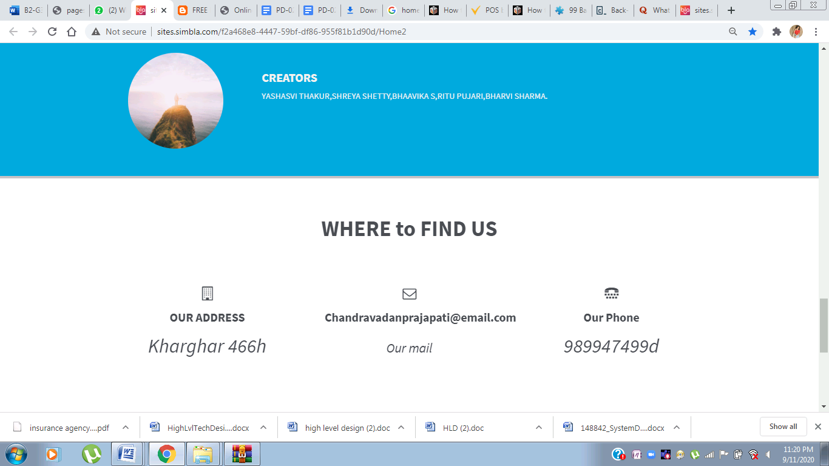

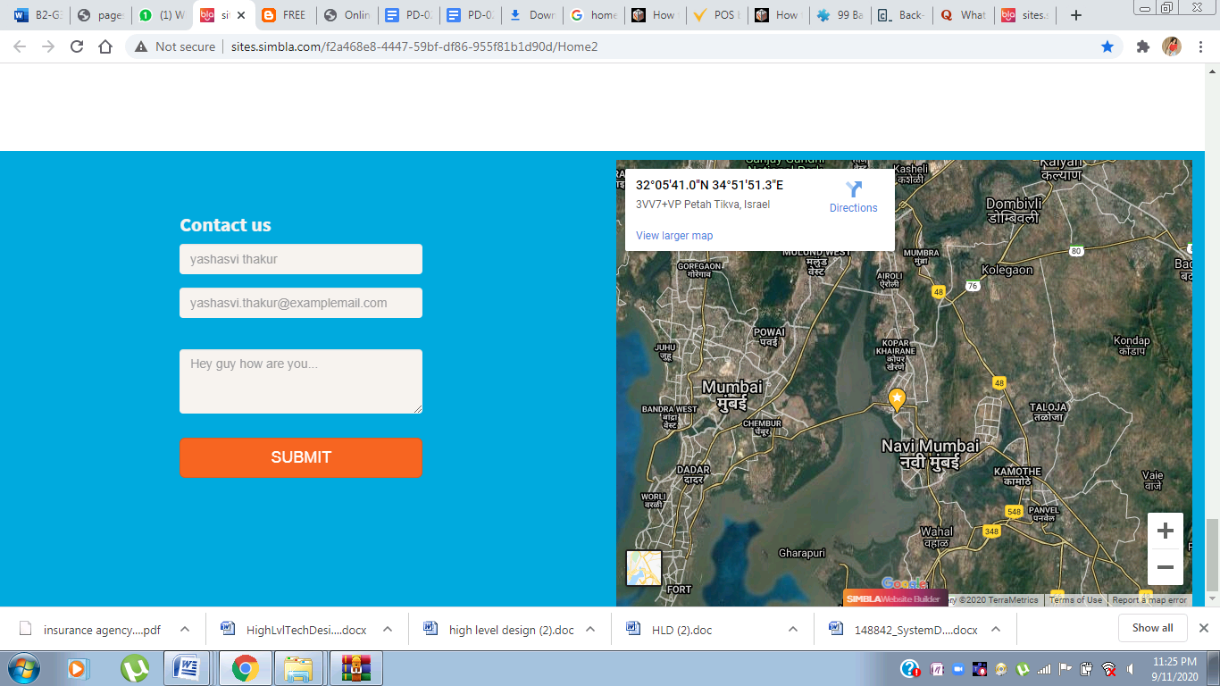

* + 1. **Commit and Post-Commit level Processing**

-> all data on the screen is static no data is retrieved or committed into the database.

* + 1. **Special Notes for the Developer**

1. Cash the static content for faster page load.
   * 1. **Issues**

**N/A**

# **Backend Design**

## **Index of Reference: Homepage <iaw-home>**

This index gives details about where all a particular function has been referred.

|  |  |  |
| --- | --- | --- |
| **Function Name** | **Calling Screen / Report /procedure / function** | **Calling Screen / Report/ Procedure / Function** |
| **sear()** | **Navigation bar** | **Searching** |
| **login()** | **Login page** | **Sign up / login details** |
| **contact_us()** | **Contact Us Block** | **Query Details** |
| **bloc()** | **Google Maps(3rd party)** | **Branch Locator** |

## 1.2 Library Name

<It is the name of the library that contains the functions. >

**1.2.1** **<Function Name>**

**1- sear()**

#### **1.2.1.1** **Brief Description / Functionality**

This feature helps the customer to navigate through the website

#### **1.2.1.2** **Parameters**

|  |  |  |  |
| --- | --- | --- | --- |
| **Parameter Name** | **Description** | **Data Type** | **Input/output** |
| Search Bar | This feature helps the customer to navigate through the website | String | Input |

#### **1.2.1.3** **Screens/Reports/Programs called**

Navigation Bar

#### **1.2.1.4** **Issues**

N/A

# 

**2: log()**

#### **1.2.1.7** **Brief Description / Functionality**

The user will be able to download proposal forms, annexure and medical documents .The customer will be able to see his/her details and all the insurances taken in the past/current.

The user will have to input details initially to get full access to the web page.

#### **1.2.1.8** **Parameters**

|  |  |  |  |
| --- | --- | --- | --- |
| **Parameter Name** | **Description** | **Data Type** | **Input/output** |
| Login | Customer will put his/her User Id and password to get access to the web page.Matching of the users username/password values with a pre-existing list of VALID/ALLOWED username/password values stored in the backend system’. | String and integer | Input |

#### **1.2.1.9** **Screens/Reports/Programs called**

Login Page

#### **1.2.1.10** **Tables Used with access mode**

NA

|  |  |  |  |  |
| --- | --- | --- | --- | --- |
| **Table Name** | **Select** | **Insert** | **Update** | **Delete** |
| User Table | Yes | -- | - - | -- |

#### **1.2.1.11** **Special Notes for the Developer**

Cash the static content for faster page load.

#### **1.2.1.12** **Issues**

N/A

**3: Contact_Us**

#### **1.2.1.13** **Brief Description / Functionality**

This will provide contact of the admin to the users to resolve queries.

#### **1.2.1.14** **Parameters**

|  |  |  |  |
| --- | --- | --- | --- |
| **Parameter Name** | **Description** | **Data Type** | **Input/output** |
| Contact Us | This function will ask the customer for his/her User Id,email and the query that the customer has.The User id and email will be compared with a pre-existing list of VALID/ALLOWED username/email values stored in the backend system’. | Query String | Input |

#### **1.2.1.15** **Screens/Reports/Programs called**

Contact Us Block

#### **1.2.1.16** **Tables Used with access mode**

NA , as the data is static.

|  |  |  |  |  |
| --- | --- | --- | --- | --- |
| **Table Name** | **Select** | **Insert** | **Update** | **Delete** |
| N/A | -- | -- | -- | -- |

#### **1.2.1.17** **Special Notes for the Developer**

#### **1.2.1.18** **Issues**

N/A

**4: bloc()**

**1.2.1.19** **Brief Description / Functionality**

Branch locator will help the customer to find the Insurance agent’s office. It can be accessed from the home page. The location will give a direct link for current location and the distance on google map (third party).

#### **1.2.1.20** **Parameters**

|  |  |  |  |
| --- | --- | --- | --- |
| **Parameter Name** | **Description** | **Data Type** | **Input/output** |
| Branch locator | Helps the customer to find the Insurance agent’s office. It can be accessed from the home page. Google Maps offers an API that allows maps to be embedded on third-party websites, | String/Integer | Input |

#### **1.2.1.21** **Screens/Reports/Programs called**

Login screen

#### **1.2.1.22** **Tables Used with access mode**

NA